**Activity 11.2- Mohammed Abdin**

**Submission Instructions:**

Your submission for this assignment should be a Word document that includes the following screenshots, each labeled for the step that the screenshot represents:

1. A screenshot of Visual Studio Code showing the app.py from the “Activity 11.2 - Cookies.zip” file.

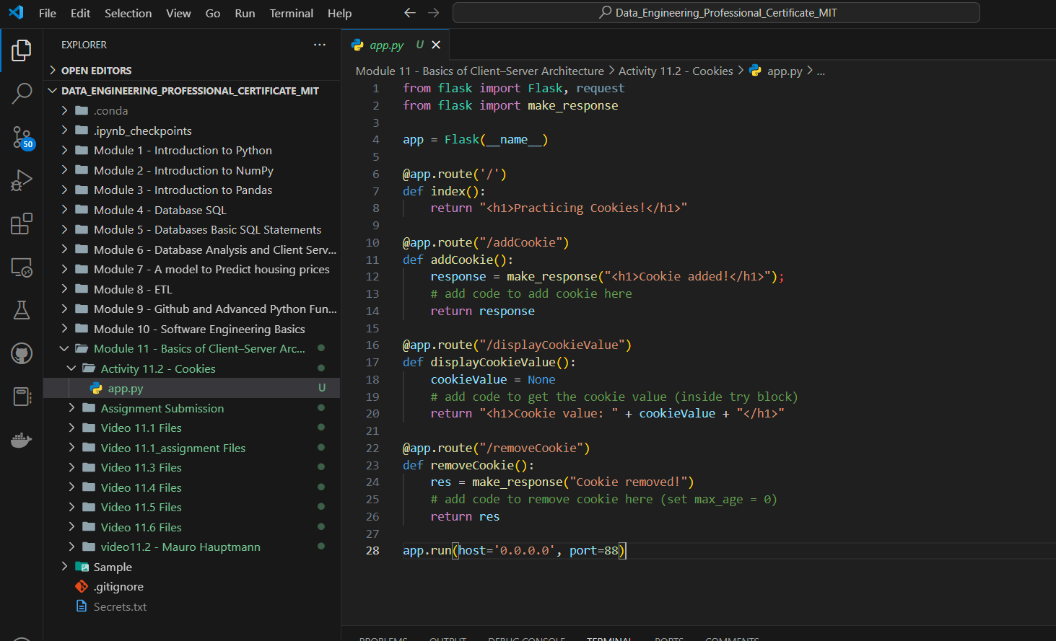

1. A screenshot of the web browser pointing to “<http://localhost:88>” and displaying “Practicing Cookies!”

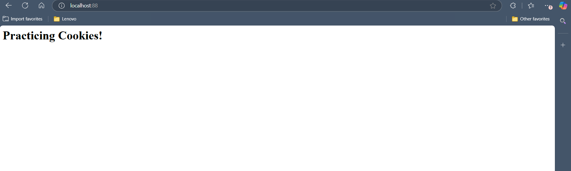

1. A screenshot of the completed *method* addCookie in app.py.

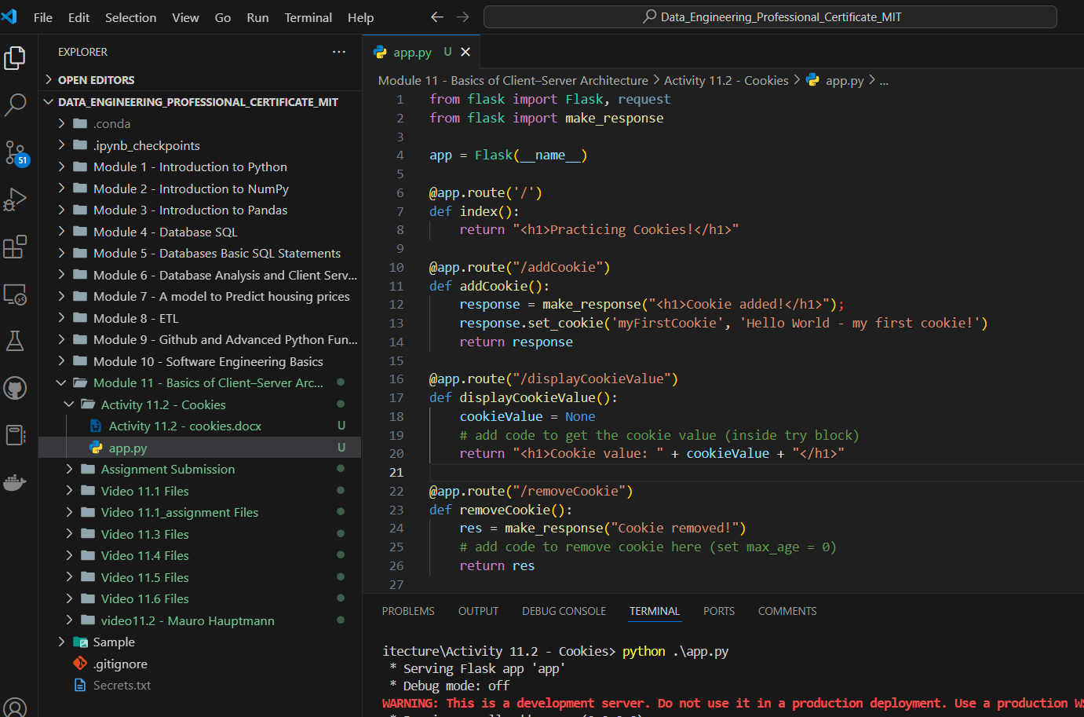

1. A screenshot of the browser pointing to “<http://localhost:88/addCookie>” and displaying “Cookie added!”

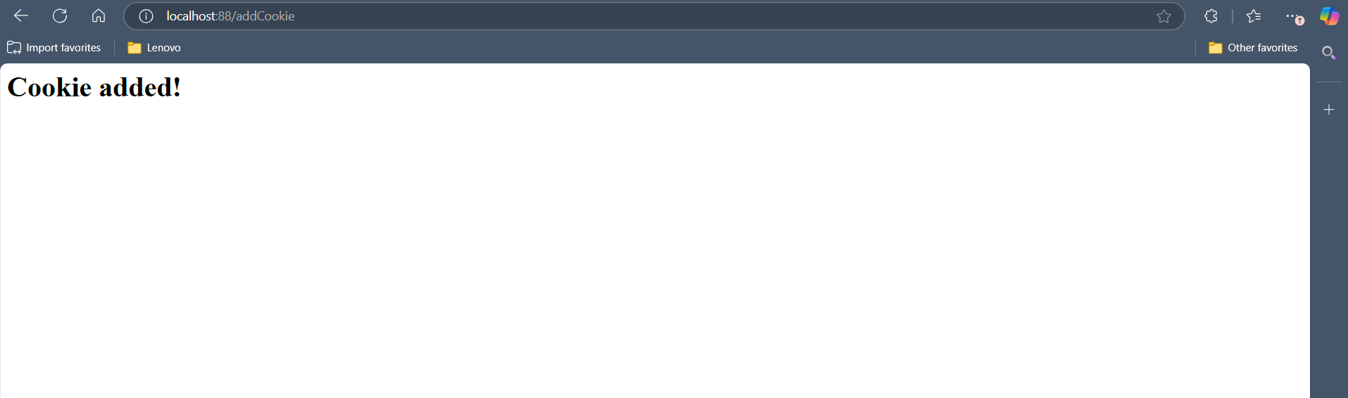

1. A screenshot of the web browser settings displaying the new *cookie* “myFirstCookie”.

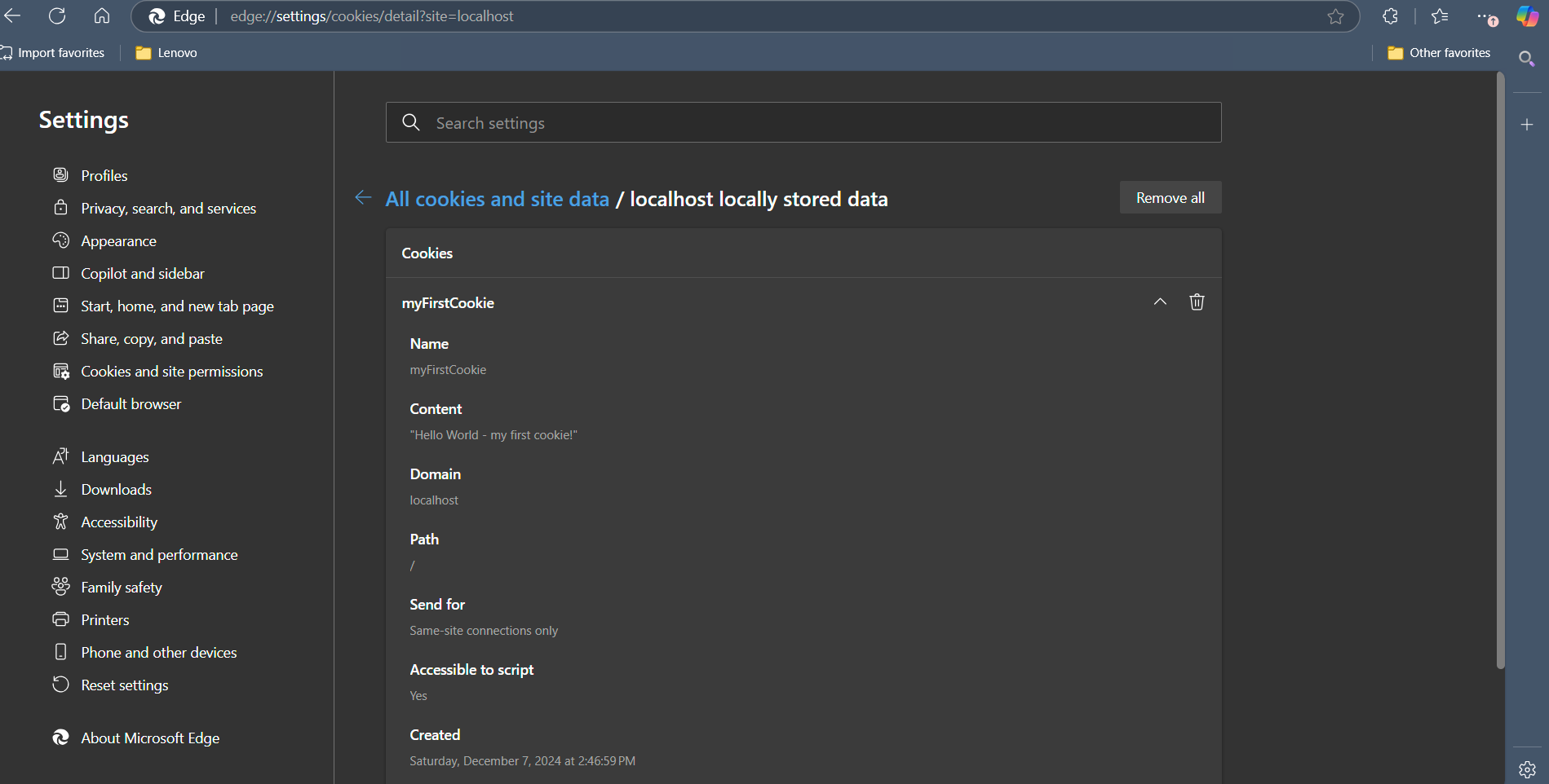

1. A screenshot of the completed *method* displayCookieValue in app.py.

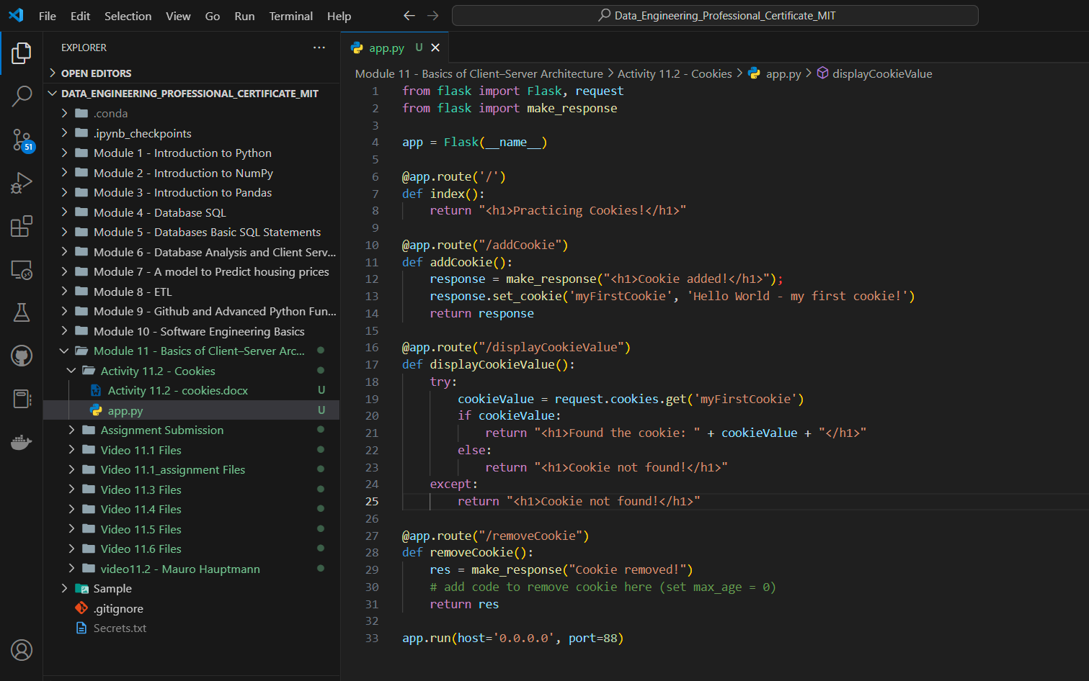

1. A screenshot of the browser pointing to “<http://localhost:88/displayCookieValue>” and displaying the *cookie* value. Note: ensure you navigate to “<http://localhost:88/addCookie>” first to add the *cookie*.

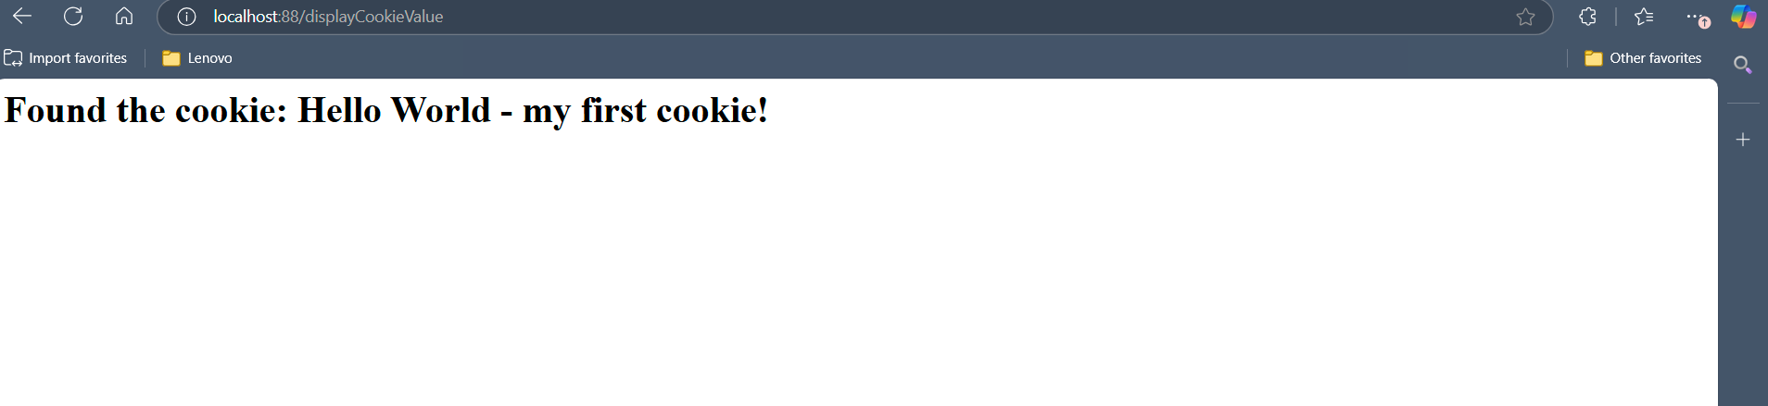

1. After removing the *cookie* “myFirstCookie” from your browser, point your browser to “<http://localhost:88/displayCookieValue>”. Your browser should display “Cookie not found!”

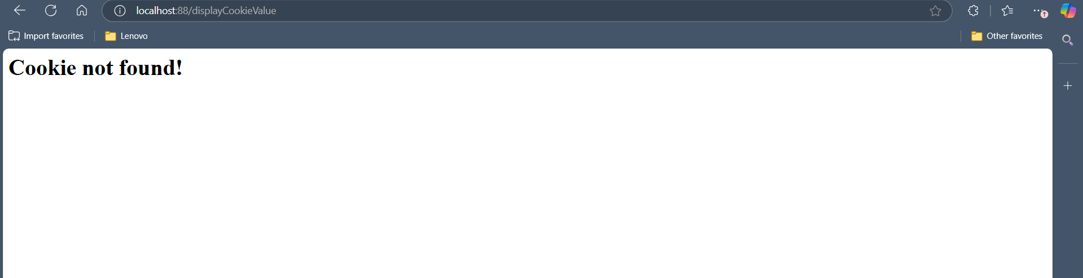

1. A screenshot of the completed *method* for removeCookie in app.py.

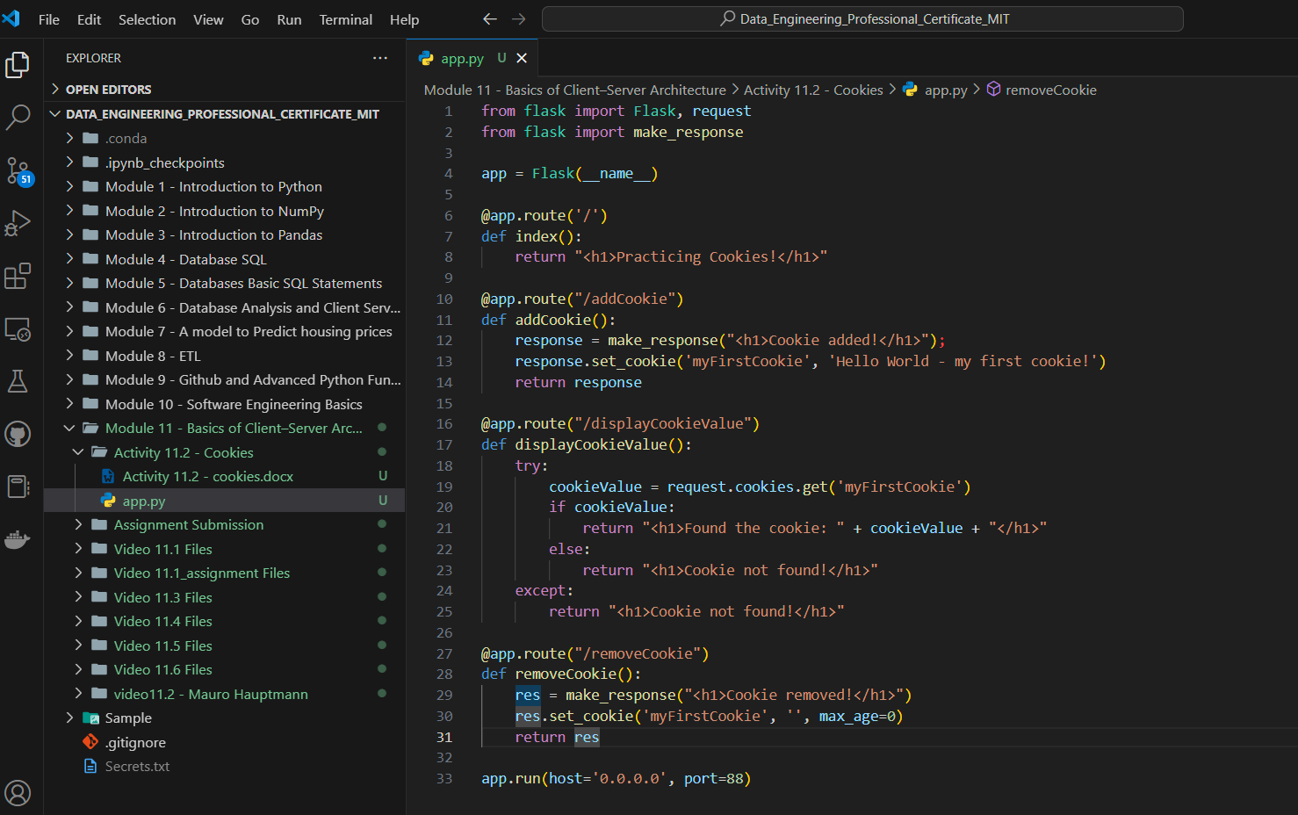

1. A screenshot of your browser settings, after pointing it to “<http://localhost:88/removeCookie>”, showing that the *cookie* has been removed.

